Business problem and Objective Formulation

Demonstrate understanding of the assigned domain and business context
Domain Understanding: While connected vehicles are presently engulfed by the core problem of relying on a reactive risk management of vehicle related incidents. This domain presents a challenge of IoT data from several sensors from huge fleet of connected vehicles thereby producing a massive dataset.

Identify the potential business problem(s) present in the dataset
- Vehicles are not maintained/serviced based on schedule for several days or months
- Too much of repair costs; and insurance claims are almost double the size of repair costs
- Drivers with less training have caused more than half of repair costs and half of insurance claims
- Vehicle type, vehicle make, vehicle fuel type do not have much difference in repair costs or claim amounts; so does the ADAS warnings have no much skewedness, making this a driver related incidents in a major way

Formulate the business objectives and analytical objectives that the team intends to address
The leadership needs to find ways to solve this problem of reactive risk management and implement a proactive risk management framework that will
- Detect and prevent issues early that will reduce the number of vehicles related incidents significantly;
- Continuously monitor risky driver behaviours, driving conditions, ADAS warnings, and vehicle conditions related data; create a model that will help create an ecosystem of safer transportation systems
- Detect anomalies, classify and label risky drivers proactively

Challenges and Constraints

Identify potential challenges associated with the problem, data, implementation, deployment, or business adoption
- Skewness exists across several features, causing a small set of data impacting the median/mean – such as in insurance claims, repair costs
- There are missing data or values for features such as battery health, driver training score
- Outliers do exist and decisions to either exclude them or include them for modeling can be challenging
- Environmental data can be orthogonal to driver behaviours
- Monitoring Driver behaviours may be a questionable application as it can invade driver privacy and concentration

Discuss assumptions, limitations, and constraints that can affect the proposed solution
- Certain driving environmental conditions or road conditions might require to be avoided altogether due to the data
- Certain drivers may be potentially not be eligible to drive due to their rash driving once the proposed solution is implemented
- Certain features such as legacy vehicle reference, fleet information, trip batch, may not be required as part of feature engineering/feature selection process
- Regions are not specified; therefore, the data is assumed to be global in nature; this can potentially lead to imperfect modelling as live data from other geographic regions are used, the models may predict imperfectly

Literature Review

Review relevant academic research
- Unsafe Driving Risk Among Commercial Truck Drivers Using Machine Learning
- AI-Based Predictive Modeling for Crash Risk Assessment and Mitigation in ADAS
- Deep Learning Based Predictive Models for Real-Time Accident Prevention

Summary of problem-solving approach in the above literature review
All the referenced 3 papers converge on the same thesis of using ML to predict incidents before they happen.
- Mehdizadeh et al. (2021) used ML on 20M miles of truck data to predict safety critical events 30 minutes ahead by combining driver and environment data
- Thesciencebrigade | Journal of Science & Technology, 2022 – fused ADAS sensor and environmental using predict
- He et al. (MIT CSAIL, 2025) used LTSM with attention mechanisms to predict road accidents before they occur using GPS and road topology.

Key techniques, methodologies and best practices
- All three papers converge on common methodology of Supervised ML for classification of incident risk, feature engineering combining driver, vehicle and environment telemetry
- The ML methods used are XGBoost, Gradient Boosting, Random Forest
- Best practices: Handling class imbalance, having larger training data and lesser test data compared to the usual 70:30/80:20 split to 90:10 split, feature importance and explainability.

Proposed Methodology
- Analytical Approach/ML Approach: Feature tiering strategy such as
  - primary tier consisting of Vehicular data such as manufacturer, fuel type, vehicle type and related
  - secondary tier of driver data such as age of driver, driver training data, driving experience, driving behaviours
  - third tier consisting of ADAS signals such as collision signals, emergency braking
  - fourth tier of environmental data such as night driving, rain fall, visibility and
  - Supplementary tier consisting of finance data, and legacy information
- Solution workflow consists of data insights and exploratory analysis, statistical modeling to understand data insights and past behaviours, removing noise and data imbalances/skewness, using classification algorithms, and ML techniques with training and test data
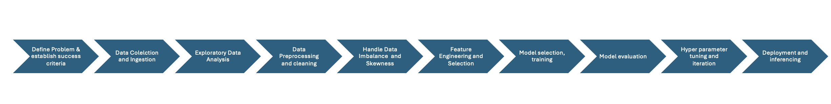
Figure 1 – Solution Workflow
- Proposed Solution Explanation: We take the raw data, explore it to understand what's happening, clean out the noise, and fix any imbalances so the model doesn't learn the wrong patterns. From there, we engineer the right features, train a classification model, and keep refining it until the results are solid before pushing anything to deployment.

Project Plan
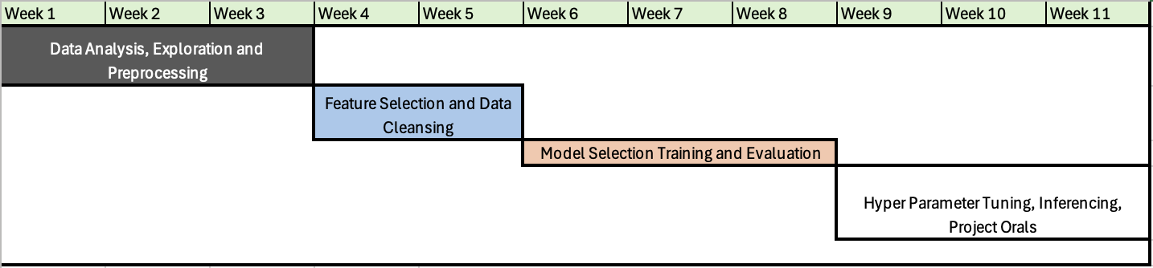

Expected Deliverables
- Data Exploratory Analysis report
- Cleansed Data set
- Feature Engineering Catalogue
- Trained Models
- Model performance report
- Deployment Inference Pipeline

Mehdizadeh et al. (2021)
Thesciencebrigade | Journal of Science & Technology, 2022
He et al. (MIT CSAIL, 2025)

